**PK NAVRATRI NIGHTS**

1. **Event Rules**

* 20 Garba Dancers, 20 Singers, 10 Fashion Talents have to register their id’s with SK employees to participate in this event.
* Talents must wear outfit as per Navratri colour dress code on pk scheduled day.
* PK match will be held between the talents from same category, Garba dancers go against garba dancer, Singers go against singer, Fashion go against fashion talent.
* Talents need to come live 15 min before the PK Battle, there will be a 15-min official PK match scheduled for the event.
* First Talent to the left on the webpage schedule, will start the performance first and will perform for first 5 – 6 Min, then next talent will perform for 5 – 6 Min.
* Will have 1 winner from each category (Garba Dancing, Singing & Fashion) based on maximum beans received in the event will bementioned in the BANNER for 3 days.
* Talents and User will be ranked on the leaderboard based on the maximum beans received and spent respectively in the event.
* Talent & User ranking will be separate for each category.
* The winner of this tournament will be decided based on the beans they receive in the Final Round.

1. **PK Categories**

* Following pk battle will be held in this pk Navratri event

2.1. PK Garba Fusion Dance Battle

2.2. PK Singing Battle

2.3. PK Fashion Battle

* 1. **PK Garba Fusion Dance:** Talents must perform the PK Garba Fusion dance for 5–6 min each during the Pk battle, and they must dress in Navratri-themed attire and colour on the Scheduled Pk day.
  2. **PK Singing Battle:** Talents must sing Navratri-related songs for 5 to 6 min each talent, and they must dress in Navratri-themed attire and colour on the Scheduled Pk day.
  3. **PK Fashion Battle:** Talents can perform a ramp walk in the Pk battle and should wear regional traditional attire, such as Gujarati, Bengali wear, etc. in accordance with the day's Navratri colour dress code.

**ROUND 1:**

* Round 1 will be conducted from 15th Oct – 19th Oct.
* 20 Garba Dancers, 20 Singers, 10 Fashion Talents will be participating.
* After all the matches are conducted, Top 12 Garba dancers, top 12 singers and top 6 fashion talents with maximum beans earned will qualify for round 2 i.e FINAL ROUND

**Round 2 (FINAL ROUND):**

* Round 2 will be conducted on 22nd Oct – 23rd Oct.
* Top 12 Garba dancers, top 12 singers and top 6 fashion talents will be selected based on the maximum beans earned in pk in Round 1 from that category.

-Schedule will be communicated by the admins

**3. Navratri Dress colour code-**

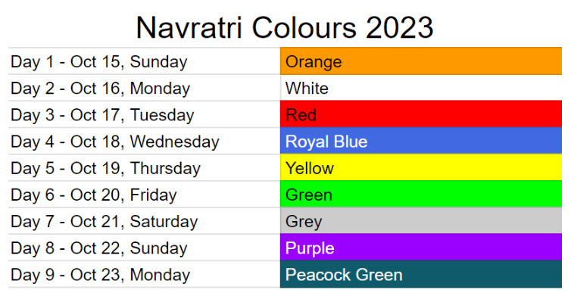

Talent must wear outfit as per the colour dress code on the day of event pk battle scheduled.

**4. Ranking and Leader board:**

* Leader Board Ranking will be decided on the basis of gems they are receiving in each round.
* Top Talents that earns maximum beans in the round 1 will qualify for the final 2nd round.
* Final round winners will be determined on maximum gems earned in the round 2.
* There will be 2 leaderboards on the webpage. 1st will be talent ranking & 2nd will be user ranking.

**4.1. Talent ranking:**

* Talent rankings will be based on the total number of beans received by the talent in that round.
* Rankings will be separate for Round 1 and round 2. Earnings of Round 1 will not be counted towards ROUND 2.

**4.2. User ranking:**

* Users will be ranked as per the beans spent in the event.
* Rankings will be separate for Round 1 and round 2. Earnings of Round 1 will not be counted towards ROUND 2.

**5. REWARDS:**

**5.1 User Rewards:**

Each round's bean pot will collect some part of the total beans, which will be split among the top ten users in each round, whoever spends 1M or more beans in that round.

|  |  |
| --- | --- |
| **Top Users** | **Winner Rewards** |
| 1 | User receives 25% of total beans pot |
| 2 | User receives 20% of total beans pot |
| 3 | User receives 15% of total beans pot |
| 4 | User receives 10% of total beans pot |
| 5-10 | User receives 5% of total beans pot |

* **User rewards for TOP 5 USERS for Round 2.**

|  |  |
| --- | --- |
| **Rank** | **Rewards** |
| 1 | 7 days Solar Entrance + 15 days GLORY profile frame + webpage mention |
| 2 | 5 days Solar Entrance + 5 days GLORY profile frame + webpage mention |
| 3 | 3 days Maharaja Entrance + 3 days GLORY profile frame+ webpage mention |
| 4 | 1 day Maharaja Entrance + 1 day GLORY profile frame+ webpage mention |
| 5 | 3 days MAESTRO profile frame+ webpage mention |

**5.2 Talent rewards**

* Following rewards will be distributed as per gems they are receiving according to given criteria in both rounds of the event for the top 2 talents.

|  |  |  |
| --- | --- | --- |
| **Rank** | **Criteria** | **Rewards** |
| 1 | 4 Million & Above | Rs 1500 Amazon E gift card Voucher |
| 2 | 3 Million & Above | Rs 1000 Amazon E gift card Voucher |

* If more than two talent meets the criteria, the top-earning talent will receive the given vouchers.
* **Talent rewards for Round 1:**

Following rewards will distributed as per gems they are receiving according to given criteria.

|  |  |
| --- | --- |
| **Criteria** | **Rewards** |
| 05 Million & Above Gems | 10 Days Audio Room theme + Profile Frame |
| 03 - 05 Million Gems | 5 Days Audio Room theme |
| 01 - 03 Million Gems | 3 Days Audio Room theme |
| 500K – 1 Million Gems | 1 Day Audio Room Theme |

* **Talent Rewards for Round 2:**

Following rewards will be distributed as per gems they are receiving according to given criteria.

|  |  |
| --- | --- |
| **Criteria** | **Rewards** |
| 10 Million & Above Gems | 15 days PK SUPER STAR BADGE + Audio theme of PK SuperStar + PK SuperStar Profile Frame |
| 05- 10 Million Gems | 10 days Audio theme of PK SuperStar + PK SuperStar Profile Frame |
| 03- 05 Million Gems | 07 days Audio theme of PK SuperStar |
| 01- 03 Million Gems | 5 days Audio theme of PK SuperStar |

- Top winner Talents of Round 2 from each category will be mentioned in the Banner for 3 days.

- Top 5 Talents and Users from round 2 will be mentioned in the web page.

- Top Talents will be mentioned in the social media from StreamKar Official A/c based on the performance.